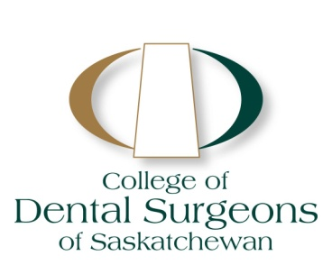

July 16, 2012

Sara Wheelwright

Trusted Saskatoon

Dear Sara:

Thank you for attending the meeting at the College of Dental Surgeons of Saskatchewan (CDSS) on

July 12, 2012 and for your presentation on the “Trusted” websites. Currently the College considers the name “Trusted” to be non-compliant with the following CDSS Bylaws:

10.2 Advertising, promotion and other marketing activities must be in good taste, accurate and not capable of misleading the public, and observe the dignity and ethics of the profession. Any conduct, either directly or indirectly, or through any medium or agent that:

1. misinterprets facts;
2. compares either directly, indirectly or by innuendo, the member's services or ability with any other practitioner, or promises or offers more effective service or better results, than those available elsewhere;
3. deprecates another member as to service, ability or fees;
4. creates an unjustified expectation about the results the member can achieve;

(h) makes statements which are not statements of fact or makes statements that cannot be proven to be accurate by the member;

Following our discussion today the College is investigating methods of engaging the public more directly to assess the services provided by our members. We appreciate our frank discussion with you and hope that it will benefit the public perception of public interest.

Sincerely,



Dr. Bernie White,

Registrar